Agreed by:

Christine Evans-Klock  UNDP Resident Representative | Signature | Date

INITIATION PLAN
for a GEF Project Preparation Grant (PPG)
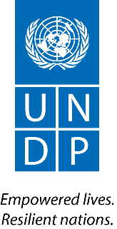
ATLAS Project: 00110427
ATLAS Output: 00109365
PIMS ID: 6178

Total budget: US$ 37,500

Allocated resources:
- GEF US$ 37,500

Project Title: Strengthening of the enabling environment, ecosystem-based management and governance to support implementation of the Strategic Action Programme of the Guinea Current Large Marine Ecosystem

Country: Regional project including Benin, Cameroon, Congo, Democratic Republic of the Congo, Cote d’Ivoire, Gabon, Ghana, Guinea, Equatorial Guinea, Guinea-Bissau, Liberia, Nigeria, Sao Tome and Principe, Sierra Leone, and Togo

UNDP Strategic Plan/Regional Programme for Africa

Output 1.4.1: Solutions scaled up for sustainable management of natural resources, including sustainable commodities and green and inclusive value chains

Gender Marker Rating: GEN 2

Initiation Plan Start Date: 15th April 2018

Initiation Plan End Date: 30th November 2018

Table of Contents

Brief Description of Initiation Plan/GEF PPG 3
Stakeholder Engagement, public discourse and other requirements 5
GEF PPG Activities 6
Component A: Preparatory Technical Studies & Reviews 6
Component B: Formulation of the UNDP-GEF Project Document, CEO Endorsement Request and Mandatory and Project Specific Annexes 7
Component C: Validation workshop and report 10
Total Budget and Work Plan for GEF PPG 11
GEF PPG Activities Timeframe and Budget 13
Mandatory Annexes 14
Annex 1: GEF CEO PIF/PPG approval letter 14
Annex 2: Summary of Consultants Financed by the Initiation Plan 16
Annex 3. Draft Terms of Reference (TORs) of Consultants Financed by the Project Preparatory Grant (GEF PPG) 17

Brief Description of Initiation Plan/GEF PPG

Objective & Final Outputs

The objective of the GEF PPG is to develop the project document for the full-size project “Strengthening of the enabling environment, ecosystem-based management and governance to support implementation of the Strategic Action Programme of the Guinea Current Large Marine Ecosystem” (GCLME project).

As described in the project concept (PIF), this project aims to strengthen the regional governance and ecosystem-based management of the GCLME by assisting member countries to build capacity for SAP implementation measures related to transboundary fisheries, biodiversity conservation and pollution reduction. The Strategic Action Programme (SAP) was endorsed by member countries in 2008, and re-affirms regional joint commitment to an ecosystem-based approach to the integrated management, protection and sustainable use of the resources of the GCLME by the people of the sixteen riparian countries. The project will be implemented through a cooperative approach between the different agencies involved (UNEP, FAO, UNIDO and UNDP).

The project will have four components:
- Strengthening of regional governance and regional and national capacities (UNEP led);
- Strengthening of fisheries governance and management in an ecosystem context (FAO led);
- Assessments, stakeholder and inter-ministerial consultations (UNDP led);
- Hot spot analysis of pollution in the GCLME and private sector mobilization (UNIDO led).

The overall approach for the project strategy and main components of the project were identified during the preparation of the PIF. However, PPG resources are needed to support detailed analyses and consultations, and to define the roles and responsibilities of different institutions for project implementation.

The purpose of this Initiation Plan (IP) is to develop a detailed set of activities for the UNDP-led component and prepare the full project document in UNDP template and GEF Request for CEO endorsement, with all required supporting documentation, including the respective co-financing letters from stakeholders from GCLME riparian countries. Technical clearance of the complete submission package requires sign off by (i) UNDP Ghana CO, (ii) UNDP Istanbul Regional Technical Advisor on Water and Oceans (W&O) and (iii) UNDP GEF Principal Technical Advisor on W&O in UNDP HQ.

This work will be carried out by one international consultant and two national consultants, with inputs from the Institut de Recherche et de Developpement (IRD) and its network in the GCLME countries. The team will report to the UNDP Ghana CO, but their deliverables will be vetted also by UNDP Principal and Regional Technical Advisors on W&O.

Documents to be consulted as background for the GEF PPG phase include:
- PIF cleared for WP inclusion or GEF Council approved PIF;
- Comments from GEF Secretariat, Council, STAP;
- Annotated UNDP-GEF Project Document Template and associated guidance included therein;
- The SAP and other bilateral/multilateral water related agreements among GCLME riparian countries;
- National Action Plans for the Implementation of the GCLME Strategic Action Programme (SAP)
- National legislations and programmes on transboundary fisheries, biodiversity conservation, pollution reduction, coastal management and climate change;
- ECOWAS directives and programmes on transboundary fisheries, biodiversity conservation, pollution reduction, coastal management and climate change;
- Transboundary Diagnostic Analysis (TDA);
- Research and knowledge material developed through past and current interventions targeting the GCLME.

The final outputs of the GEF PPG will be:
- UNDP-GEF Project Document (ProDoc), using the 2017 standard template.
- Mandatory annexes to the ProDoc, including gender analysis and action plan, and stakeholder engagement plan, among others, and project specific annexes (e.g. landscape profile, institutional and legal analysis, feasibility studies etc).
- GEF CEO Endorsement Request.
- GEF Tracking Tool
- Letters of Co-financing
- Validation Workshop report (as appropriate for projects with a moderate and high SESP risk rating).

Any additional studies and other reports produced under the GEF PPG and not included in Annex to the project document will be saved for future reference.

Key Dates for the GEF PPG

Milestone | Date | Notes
Contracting team of international and national consultants | Within first 1.5 months of PPG implementation
PPG Inception meeting | Within first 3 months of PPG implementation
Planned date for 1st draft submission to UNDP | August 2018
Planned date of internal clearance by both GEF Regional Technical Advisor and UNDP Principal Technical Advisor | December 2018 | Planned date of internal clearance by UNDP GEF Regional Office and UNDP New York
Planned date of first submission to GEF Sec | January 2019 | Planned date of first submission date to GEF Secretariat
Absolute latest Internal submission date for UNDP-GEF review and clearance (in case of delays) | February 2019 | The deadline internal submission date must be at least two (2) months prior to CEO Endorsement Deadline
CEO Endorsement Deadline after which the project will be cancelled. | May 30th, 2019 | The GEF Cancellation Policy means that failure to submit a ProDoc and CEO ER to the GEF Sec by this deadline will lead to the automatic cancellation of the project by the GEF Secretariat.

Management Arrangements

The Initiation Plan will be directly implemented by UNDP. UNDP will be responsible for the selection and recruitment of PPG consultants, maintaining project disbursements, regular financial reporting, and will have full oversight of all procurement and activities required to develop a Project Document. UNDP CO in Ghana will act as the lead UNDO CO in both the PPG and the implementation phases of the project.

The preparation of the full-fledged project will be conducted in close consultations with the Abidjan Convention Commission, which will provide technical input into the UNDP Project Document, GEF CEO Endorsement Document and the Tracking Tool, along with input into the project management arrangements. UNDP will also work in close collaboration with the other UN Agencies participating in this project and developing their own components, in order to have a coherent and comprehensive full project proposal for submission to the GEF.

The GEF PPG team will be composed of the following consultants:
- International Consultant on International Waters Management Project Design - Team Leader;
- 2 national Consultants on International Waters Management (1) and gender (1);
- IRD partners and their network.

Draft Terms of Reference (TORs) for each team member is included in Annex 3 of this Initiation Plan.

Stakeholder Engagement, public discourse and other requirements

To ensure strong countries ownership, and in line with the stakeholder engagement requirements outlined in UNDP’s Social and Environmental Standards (SES), the development of the project will be done in full consultation and close engagement with government, CSO and other relevant stakeholders of the GCLME riparian countries – in particular those who will benefit from and be directly involved in the implementation of the project (i.e. direct project beneficiaries). A list of these stakeholders will be prepared and included in Annex to the project document.

If the Social and Environment Screening Procedure (SESP) included in Annex to the project document, has an overall safeguard risk rating of moderate or high, the following disclosure requirements apply:

- A final validation workshop report will be prepared summarizing the outcomes of the validation workshop and other consultations undertaken during the PPG phase. This report must demonstrate strong countries ownership and will become a key reference document should an environmental and social safeguard complaint/grievance be filed during project implementation.
- Before CEO endorsement (if appropriate given the GEF cancellation policy) or at the latest by the LPAC meeting, the UNDP-GEF project document, SESP and related management plans, and other relevant information/documents (e.g. ProDoc annexes) will be made available to the public on the UNDP website or open.undp.org. It is recommended to make these documents available for 30 days in advance of the LPAC meeting for moderate risk projects, and 120 days in advance for high risk projects.

GEF PPG Activities

Component A: Preparatory Technical Studies & Reviews

The following technical studies and reviews will be conducted, building on the PIF and the comments received to the PIF (e.g. from GEF Council and STAP).

- Desktop and field-based studies and data collection

This research should produce the background information required to prepare the ProDoc and CEO Endorsement Request, including but not limited to:

- Development challenge and strategy (including threats, problems and barrier assessment);
- Review of national policy and legislative frameworks;
- Problem and solution trees developed in consultation with project stakeholders, for a robust Theory of Change (to be prepared in Component B, below);
- Review of relevant past and ongoing projects in the field of interest for lessons; and
- Any other analyses required to address all comments on the PIF received from GEF Secretariat, GEF Council members and STAP.

This activity will involve data collection and review on the national legislative controls and strategic planning in the area of ocean and coastal waters in general. Further it will be looking at the recent and current actions being taken in the countries with respect to ocean and coastal waters management (including monitoring and evaluation measures) to enable the precise design of the future GEF project. The desk top and field based studies and data collection will be led by the International Consultant with inputs from the national consultants and IRD and the information will all be put together in a baseline data report.

- Gender Analysis

A gender analysis will be prepared to fully consider the different needs, roles, benefits, impacts, risks, differential access to and control over resources of women and men (including considerations of intersecting categories of identity such as age, social status, ethnicity, marital status, etc.) given a project’s context, and to identify appropriate measures to address these and promote gender equality and women’s empowerment. The analysis will form the basis of a Gender Action Plan and Budget to guide gender mainstreaming during project implementation. The Gender Analysis, and the Gender Action Plan and Budget must be attached as Annexes to the Project Document. See guidance available here. The gender analysis will be carried out by the respective Gender Specialists.

- Environmental and Social Safeguard Assessments

The lead person tasked with carrying out the Social and Environmental Safeguards Screening Procedure (SESP) will be the international consultant.

The purpose of these assessments is to identify ways to avoid negative environmental and social impacts where possible (e.g., through site selection). If risk avoidance is not possible, then mitigation and management measures must be identified, in line with the UNDP Social and Environmental Standards (see Section B-f below). If the required assessments cannot be undertaken or finalized during the PPG, they must be completed during the first phase of project implementation. The SESP will be carried out by the International Consultant in close cooperation with the team of national consultants, IRD and its partners.

- Financial planning

The project budget will be identified with detailed budget notes provided. Co-financing will be confirmed and sources of funding clearly identified through series of consultations with partners to ensure a coherent and sustainable financing package for the project, including post-GEF grant phase to the extent possible. The respective co-financing letters obtained. The consultants and UNDP COs will work towards confirming the national co-financing and securing co-financing letters.

- Integration with development plans, policies, budgets and complementary projects:

Analysis of the relevant existing national development plans, programmes and policies and complementary programmes in the fields relevant to ocean and coastal management will be conducted, along with the budgets allocated by the Government and donors to support these strategic programmes and projects, respectively.

Component B: Formulation of the UNDP-GEF Project Document, CEO Endorsement Request and Mandatory and Project Specific Annexes

Based on the technical studies and reviews undertaken under Component A (detailed above), the full UNDP-GEF Project Document will be developed (following the 2017 annotated UNDP-GEF Project Document available here), and the GEF CEO Endorsement Request (available here) will be prepared.

The GEF PPG Team Leader will be responsible for the consolidation and finalization of all required materials. The national consultants and IRD will provide information and data on a) the baseline data and other information required to write the project document. The IRD will provide inputs to the IC at the national level for GCLME countries with the support of its network of partners in the LME.

This component will focus on the preparation of the UNDP-GEF Project Document, including the following areas, which do not exhaustively capture the required Pro Doc content:

- Theory of Change

The detailed theory of change (ToC), based on the studies and data collection undertaken in Component A, will be developed. The selected approach will be identified, with a clear rationale backed by credible evidence, integrating gender concerns into the approach. Additional guidance is available in the Annotated UNDP-GEF ProDoc template.

- Results Framework

Based on the studies and data collection undertaken in Component A, the Results Framework will be further defined with appropriate Objective-level and Outcome-level quantitative and qualitative SMART indicators and mid-term and end-of-project targets. It will be designed in line with the following parameters:
  - Do not include outputs or activities in the results framework. Outputs and corresponding indicators can be included in the results section and/or in Annex to the project document.
  - Prepare a maximum of 2-3 indicators for the Objective and each Outcome. Aim to keep the total number of indicators in the results framework (and that require annual reporting to the GEF) to maximum of 15-16.
  - Give special attention to include gender-responsive outcomes and other socio-economic benefits.
  - Collect baseline data for each indicator using existing national sources when feasible.
  - Disaggregate indicators by sex, including number of direct project beneficiaries.
  - Set realistic mid-term targets and end-of-project targets that can be achieved by project closure.
  - Summarize risks and assumptions, and sources of verification/data.

See the annotated UNDP-GEF Project Document template for additional guidance on developing the Results Framework.

- Monitoring and Evaluation (M&E) Plan and Budget

The on-the-ground monitoring could be undertaken by national institutes/universities as appropriate. Clarify the roles of various groups involved in project M&E, how project-level monitoring links with data collected at the national level, and specify the frequency of monitoring. Specify monitoring tools to be used; clarify responsibilities for completing the mid-term and terminal GEF Tracking Tools (see below). Complete the M&E budget included in the UNDP-GEF Project Document noting that the total budget should not exceed 5% of the total GEF grant.

- Stakeholder Engagement Plan

Based on the consultations undertaken during the PPG phase, a Stakeholder Engagement Plan will be developed.

- Gender Action Plan and Budget

Based on the Gender Analysis conducted in Component A, the Gender Action Plan and Budget will outline the gender-specific outputs to be delivered during project implementation in order to promote gender equality and women’s empowerment and to ensure that inequalities are not exacerbated. As part of the work of preparing the Gender Action Plan, indicators should be proposed for inclusion in the Results Framework to facilitate the monitoring of the proposed gender mainstreaming actions.

- Social and Environmental Standards

In line with the assessments conducted during Component A (above) and in line with UNDP’s Social and Environmental Standards (SES) policy and all associated SES Guidance Notes, the SESP will be finalized and all moderate and high risks identified in the SESP will be reflected in the risk table and risk section of the project document.

Mitigation and management measures for moderate and high risks will be developed and included in the project document, or included as a separate management plan in Annex to the project document, as required per UNDP’s SESP. If the mitigation and management measures cannot be fully detailed at the PPG phase (e.g. sites have not been determined), an environmental and social management framework (ESMF) will be prepared outlining the steps to be taken during the first phase of project implementation to address the moderate and high risks. The ProDoc must clearly state that none of the associated project activities will commence until: the assessment(s) have been completed; the required management plan(s) have been prepared; the plan(s) have been disclosed and approved by the Project Board.

- GEF Tracking Tool(s)

The required GEF Tracking Tool related to the International Waters focal area will be prepared, in line with the relevant GEF objectives, and included as an Annex to the ProDoc. Indicators from the GEF Tracking Tool can be included in the Results Framework as appropriate. See the GEF’s website for the most up-to-date templates as these may change.

The lead on a, b, c, d, e, f and g above will be carried out by the international consultant.

- Project Management Arrangements

Based on the stakeholder analysis and consultations undertaken in Component A above, agreement(s) on project management and governance arrangements—including roles, responsibilities and accountabilities of lead and partner Agencies—will be secured early in the project development phase and will be fully detailed in the ProDoc. UNEP in consultation with the RTA (IRH) and other involved GEF agencies’ focal points will take the lead on defining the project management arrangements in close consultations with the UNDP COs. During the PPG stage roles of all the key stakeholders to be involved in project implementation will be identified.

- Completion of the required official endorsement letters

These letters include the official letters on co-financing guarantee(s) from participating government institutions, bilateral development partners, multilateral development partners, NGOs, private sector or others who wish to provide cash or in-kind contributions to the project.

Within 6 weeks of the signing of contracts the national consultants will submit their reports (a) draft baseline data report and other reports required. The IRD is also expected to provide its inputs within 8 weeks after this IP is signed and PPG activities have started. Within 6 months of the signing of contract, the international consultant will submit all draft documents, including draft project document and draft GEF request for CEO Endorsement. A GEF OFP endorsement letter will also be required for any new participating countries to a global or regional program/project that was not included with the PIF/PFD submission. Updated GEF OFP endorsements letters are also required if the requested GEF grant amount has changed since PIF/PPG approval.

Component C: Validation workshops and report

1 regional validation workshop will be held with the relevant stakeholders to present, discuss and validate the project activities, and the final draft of the UNDP-GEF project document, as well as other documents for the submission to GEF Secretariat. The validation workshop will discuss the project results framework matrix and agree on roles and responsibilities of all parties involved in the implementation of the project. Considering the budget constraints, the validation workshop will be held in parallel to Abidjan Convention Commission regional meeting to be held in October or November 2018.

At least one month prior to the validation workshop the international consultant will circulate to all stakeholders the draft complete documentation package so that all stakeholders have a chance to get acquainted with the project.

Within 1 month of the validation workshop, the international consultant will submit to UNDP a complete draft documentation package for review and technical clearance.

Total Budget and Work Plan for GEF PPG

Award ID: | 00110427 | Output ID: | 00109365
Award Title: | Strengthening of the enabling environment, ecosystem-based management and governance to support implementation of the Strategic Action Programme of the Guinea Current Large Marine Ecosystem
Business Unit: | GHA10
Project Title: | Strengthening of the enabling environment, ecosystem-based management and governance to support implementation of the Strategic Action Programme of the Guinea Current Large Marine Ecosystem
Project (PIMS) ID: | 6178
Implementing Partner: | UNDP

GEF Outcome/Atlas Activity | Responsible Party | Fund ID | Donor Name | Atlas Budgetary Account Code | ATLAS Budget Description | Amount US$ | Budget Note
Project preparation grant to finalize the UNDP-GEF project document for project “Strengthening of the enabling environment, ecosystem-based management and governance to support implementation of the Strategic Action Programme of the Guinea Current Large Marine Ecosystem” | UNDP | 62000 | GEFTF | 71200 | International Consultant | 17,500 | A
 |  |  |  | 71300 | Local Consultant | 10,500 | B
 |  |  |  | 71600 | Travel | 5,000 | C
 |  |  |  | 75700 | Trainings and Workshops | 4,500 | D
 |  |  |  |  | PROJECT TOTAL | 37,500

Budget Notes:

Budget Note | Items | Total estimated person weeks | Budget | Budget Note
A – International Consultant | UNDP Prodoc, GEF RCE, GEF Tracking Tool | 5 | 17,500 | Please see Annex 3 for key responsibilities and ToRs.
B – National Consultant | Gender Analysis | 3 | 3,000
B – National Consultant | Based on IRD inputs and, in consultation with the Team Leader, collect additional relevant information | 3 | 7,500
C – Travel | Trips to and inside GCLME countries for consultations |  | 5,000 | Travel for:  (1) Airfare and DSA for the international consultant;  (2) Local travel of experts;  (3) Participation of GCLME country representatives, as appropriate, in working meetings and validation workshops;  (4) Consultations with international stakeholders.
D – Working meetings and workshops | Inception meeting and validation Workshops |  | 4,500 | Stakeholder consultations and validation meeting: Venue, facilitation, interpretation, as necessary, and materials

GEF PPG Activities Timeframe and Budget

PPG Activity | Mar 2018 | Apr 2018 | May 2018 | Jun 2018 | July 2018 | Aug 2018 | Sep 2018 | Oct 2018 | Nov 2018 | Dec 2018 | Jan 2019 | Feb 2019 | Mar 2019 | Apr 2019 | May 2019 | Responsible party
Component A: Preparatory Technical Studies & Reviews |  |  |  |  |  |  |  |  |  |  |  |  |  |  |  | UNDP
Component B: Formulation of the UNDP-GEF Project Document, CEO Endorsement Request and Mandatory Annexes |  |  |  |  |  |  |  |  |  |  |  |  |  |  |  | UNDP
Component C: Validation workshops and validation workshop report |  |  |  |  |  |  |  |  |  |  |  |  |  |  |  | UNDP
Submission to GEF Sec and Approval |  |  |  |  |  |  |  |  |  |  |  |  |  |  |  | UNDP

Mandatory Annexes

Annex 1: GEF CEO PIF/PPG approval letter

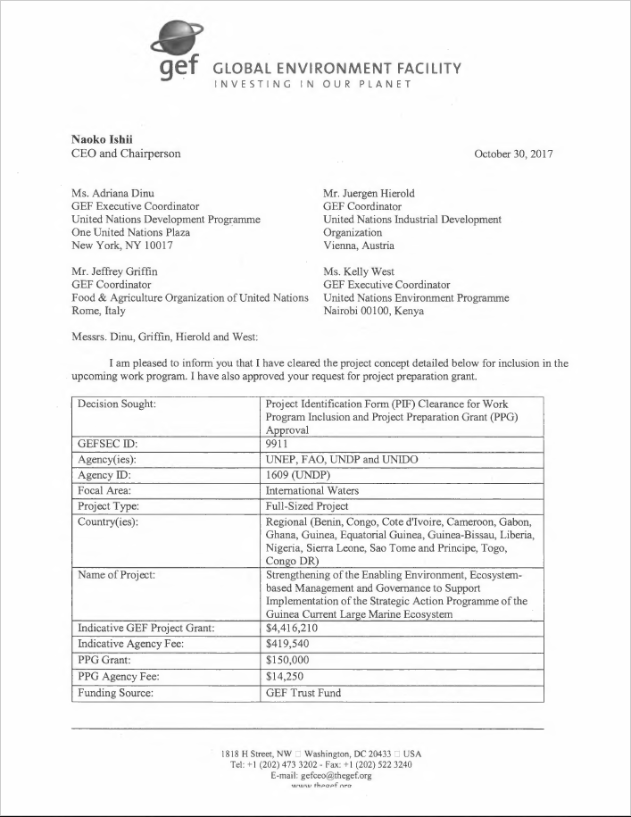

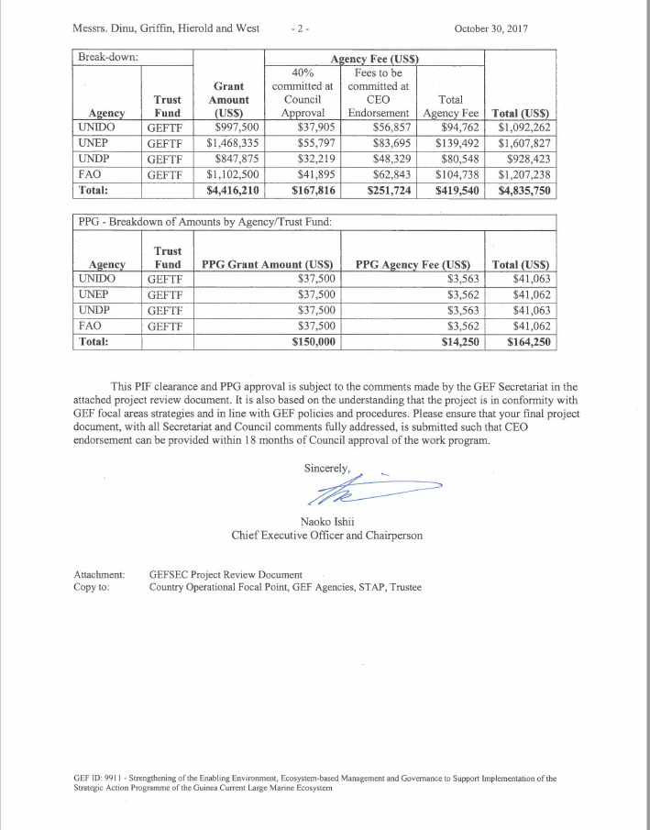

Annex 2: Summary of Consultants Financed by the Initiation Plan

Summary Tasks to be Performed

International consultant
International Consultant on International Waters Management Project Design - Team Leader – 25 working days
Local Consultants
National Consultant on gender – 10 working days
National Consultant on International Waters Management – 15 working days

Annex 3. Draft Terms of Reference (TORs) of Consultants Financed by the Project Preparatory Grant (GEF PPG)

Position, Type and Cost | Role, Deliverables and Qualifications
International Consultant on International Waters Management Project Design - Team Leader)  Position: International Waters Project Development Specialist (GEF PPG Team Leader)  Type: IC  Cost per person week: USD 700  Number of person weeks needed: 5 weeks (25 working days) | Role  The International Consultant on International Waters Management Project Design - Team Leader will be the GEF PPG Team Leader and will be responsible for quality assurance and timely preparation of all reports and documentation, including the finalized UNDP Project Document (ProDoc) and CEO Endorsement Request and all the mandatory and project specific Annexes and supporting documentation. S/he will be responsible for managing all consultants on the GEF PPG Team, and coordinating the Team’s work. The International consultant will be also responsible for liaising with the key project international stakeholders to clearly define and describe their role in the project implementation process. The different accredited agencies have agreed to recruit the same IC to ensure the coordination between the outcomes.  Deliverables  - Management of the GEF PPG Team  - Define and submit a detailed methodology and work plan with clear delegation of responsibilities for the National Consultants (NC);  - Ensure that project development is participatory, gender-responsive and based on extensive stakeholder engagements; and  - Verify and ensure that all project components are technically sound and cost effective.  - Preparatory Technical Studies and Reviews (Component A): With inputs from the national consultants, as detailed in their respective TORs, and the IRD:  - Compile baseline/situational analysis for the full-size project (FSP). This will include a precise definition of baseline projects, activities, budgets, goals and co-financial links to GEF outcomes; definition of GEF incremental value per outcome and output; and presentation of results of the incremental cost-analysis in matrices as appropriate (and will be included in the prodoc), and advise the national expert on International Waters Management on additional information to be provided;  - Lead the development of the project results framework (PRF) to be included as an annex to the project document and discussed at the validation workshop and later finalized;  - Oversee the stakeholder analysis and consultations and ensure that they are complete and comprehensive;  - Ensure the preparation of the gender analysis and ensure its findings are meaningfully integrated into the project’s strategy, theory of change and results framework;  - Ensure action points, including risk assessments, from the UNDP Social and Environmental Screening Procedure (SESP) at the PIF stage (“pre-screening”) are fully implemented during the PPG, and update that screening in an iterative fashion throughout the PPG, as appropriate;  - Oversee the consultations with partners regarding financial planning; and  - Ensure completion of any additional studies that are determined to be needed for the preparation of the ProDoc and all other final outputs.  - Formulation of the ProDoc, CEO Endorsement Request and Mandatory, International Waters Tracking Tool and Project Specific Annexes (Component B): With inputs from the other consultants, as detailed in their respective TORs, and IRD and based on international best practice:  - Develop, present and articulate the project’s theory of change;  - Develop the Results Framework in line with UNDP-GEF policy;  - Develop a detailed Monitoring and Evaluation Plan and Budget;  - Oversee and ensure the preparation of a Stakeholder Engagement Plan;  - Oversee and ensure the preparation of a Gender Action Plan and Budget;  - Update the SESP based on assessments undertaken during Component A, and ensure the development of environmental and/or social management plan(s) for all risks identified as Moderate or High in the SESP;  - Prepare the required GEF tracking tool(s);  - Secure and present agreements on project management arrangements with clearly defined roles of stakeholders in project management;  - Ensure the completion of the required official endorsement and co-financing letters; and  - Synthesize all analyses, studies, etc. that are prepared under Components A and B to produce the draft UNDP-GEF ProDoc, GEF CEO Endorsement, and all mandatory and project specific Annexes, using the required templates.  - Validation Workshop (Component C):  - Lead the preparation of the validation workshop to present, discuss and validate the final draft ProDoc and mandatory and project specific annexes, with a special focus on the SESP and any management plans;  - Oversee all necessary revisions that arise during the workshop; and  - Ensure completion of Validation Workshop Report.  - Final Deliverables:  - Consolidation of all technical and consultation inputs including from national stakeholders, UNDP, GEF Secretariat, STAP and GEF Council, into a well written and concise UNDP ProDoc with all required sections and Annexes, in line with the standard UNDP-GEF ProDoc template and annotated guidance;  - Completion of the GEF CEO Endorsement Request;  - All documentation from GEF PPG (including technical reports, etc...); and  - Validation Workshop Report.  Payment Schedule  - 20% following presentation and acceptance of methodology and workplan (prior to missions)  - 40% following presentation and acceptance of draft UNDP prodoc and GEF RCE;  - 25%Following final UNDP-GEF review and clearance of the UNDP prodoc, GEF RCE, and all the required project specific annexes;  - 15% following the GEF Secretariat approval of the final UNDP prodoc, GEF RCE, International Waters Tracking Tool and all the required project specific annexes; presentation of acceptance of final UNDP prodoc, and GEF RCE and all other supporting documents.  Qualifications  - Master’s degree or higher in a relevant field, such as water or coastal management, environmental management etc.;  - Minimum 15 years of demonstrable experience in the technical area of water, coastal or ocean management, international waters or related fields;  - Previous proven experience in successfully preparing GEF projects for UNDP or other international agencies that were approved within 18 months of the start of the assignment;  - Previous experience of working in the GCLME riparian countries in the international waters thematic area will be an asset.  - Previous experience related to managing or researching international waters is an advantage;  - Strong writing and communication skills;  - Fluency in English is required (knowledge of French is an advantage but not required).
National Consultant on International Waters Management  Type: NC  Cost per person week: USD $2,500  Number of person weeks needed: 3 weeks (15 working days) | Role  - To analyse the PIF and provide inputs to the project proposal in coordination with the inputs provided by IRD;  - To make an inventory of relevant materials to be used in the development of the project proposal;  - To liaise with stakeholders to build strong country ownership of the project and support for project efforts;  - To provide expert inputs and assist in organization of the national and international stakeholder working meetings;  - To advise on the development of the budget proposal, costing estimates, risk analysis, M&E plan, logical framework, stakeholder involvement;  - To assist in obtaining co-financing letters; and  - To provide additional inputs as required to fulfil the duties to ensure successful finalization of the project document.  Payment schedule  80% upon the submission of the report and approval of the IC  20% upon GEF CEO endorsement of the project  Qualifications  - Master’s degree or higher in a relevant field, such as water or coastal management, environmental management etc.;  - Minimum 7 years of demonstrable experience in the technical area of water, ocean or coastal management, international waters or related fields;  - Previous proven experience in successfully supporting the preparation of International Waters projects;  - Previous experience of working in the GCLME riparian countries in the international waters thematic area will be an asset.  - Previous experience related to managing or researching international waters is an advantage;  - Good writing and communication skills;
National Consultant on gender  Type: NC  Cost per person week: USD $1,500  Number of person weeks needed: 2 weeks (10 working days) | Role  - Gender analysis of the project’s results and resources framework to ensure project’s interventions and results promote gender equality.  - Conduct gender analysis with stakeholders using appropriate gender analysis tools.  - Develop action plan for incorporation of gender aspects in the project, with quantifiable baseline and target indicators, as per GEF and UNDP guidance and based on the results of gender analysis.  - Ensure project’s results and resources framework promote gender equality  - Support project formulation team to provide gender data in the development of the project document.  - Analyze the data collected and write a report in 3 copies to make it available to the project focal point, the international consultant and UNDP.  Payment schedule  80% upon the submission of the report and approval of the IC  20% upon GEF CEO endorsement of the project  Qualifications  - Master’s degree or higher in social studies, gender or related field;  - Minimum 7 years of demonstrable experience in gender-related project formulation;  - Previous proven experience in successfully preparing gender analysis;  - Previous experience of working in the GCLME riparian countries in the international waters thematic area will be an asset.  - Good writing and communication skills;

Please verify with the UNDP-GEF team that the correct templates are being used.

